Project -2
- Go to s3 console
- Create a s3 bucket (bucket name should be same as domain name)

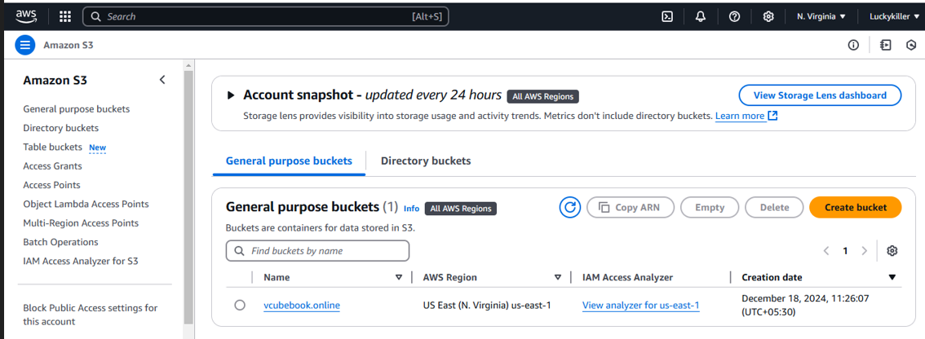

- Upload a file in bucket for static web hosting for that we need to upload .html file
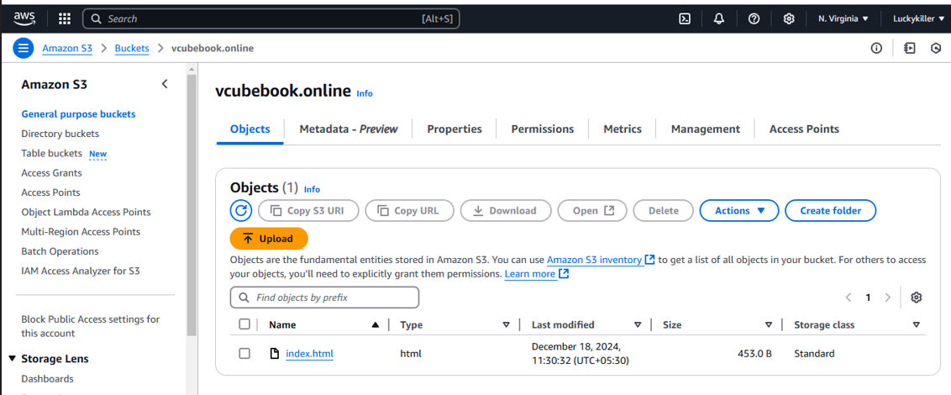
- Need to enable static web hosting for that open bucket and click on properties
- Now create json policy for that click on permission

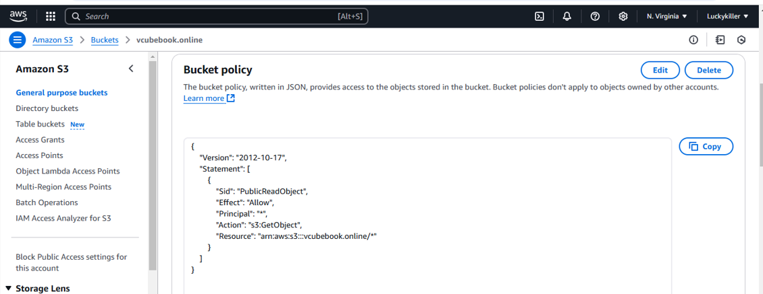

- Once we created a policy we will get static web hosting url
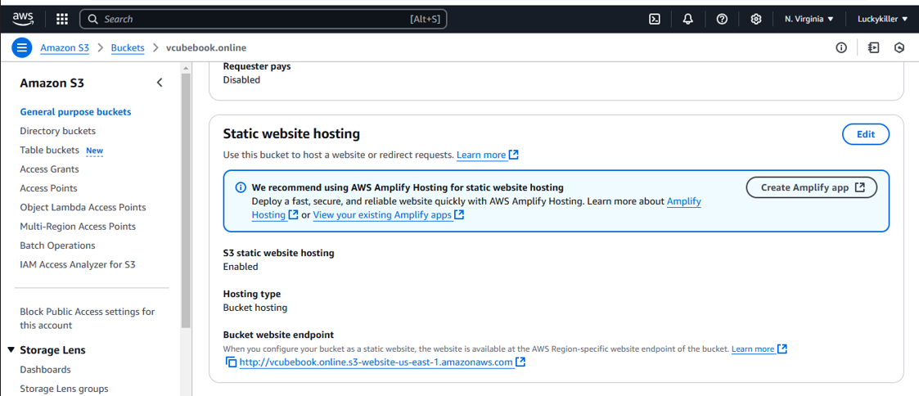

- Copy the url and paste it on web that we will get frontend page
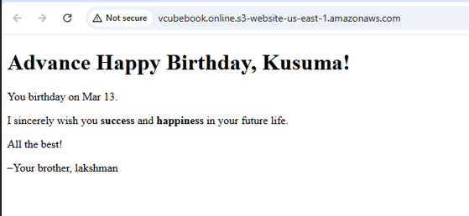

- Now goto Route 53 and create hosted zone
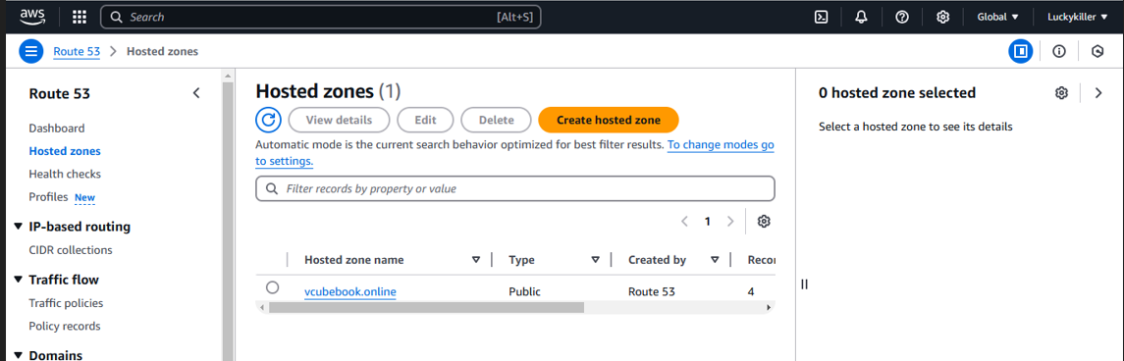
- Now creare a new record in hosted zone
- In record select s3 static web hosting
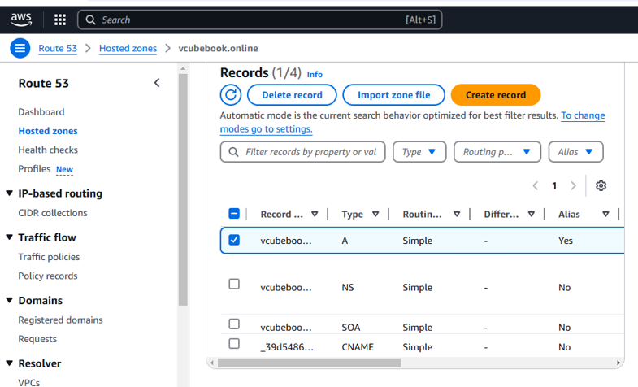
- We need to map our naming servers to domain name in hostinger
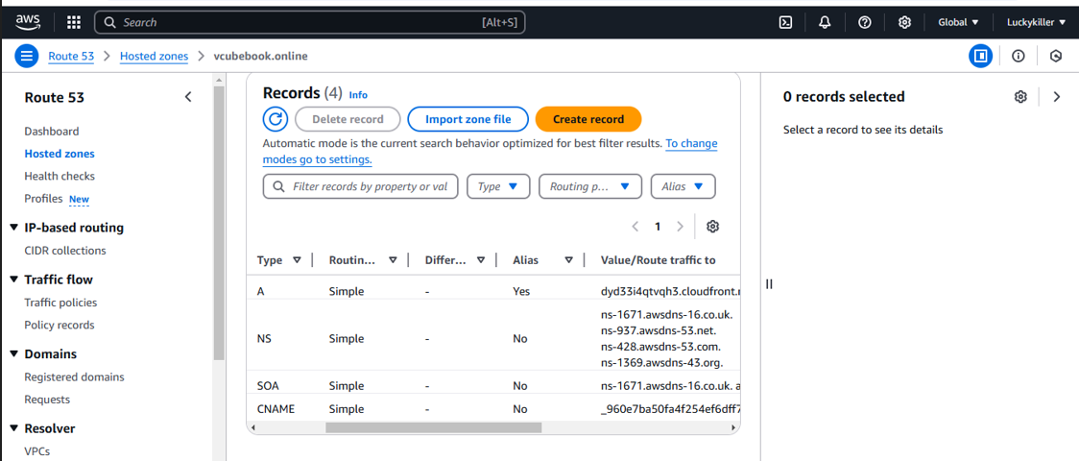

- Now can access our html file with domainname shows in below figure
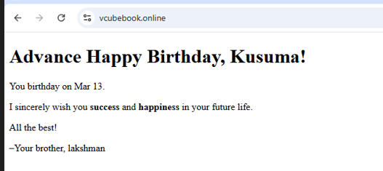
- Now we can access our frontpage through static web hosting and domain name
- But it is connecting like not secure


- Here our main aim is to connect as secure connection
- To connect secure we need to create certificate in ACM
- Go to ACM console and request certificate
- request went successful but it will remain in “pending validation” status until you valide it through DNS. For that click on “View certificate”
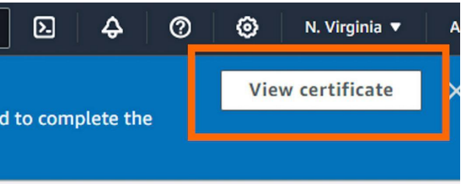

- Click on Create records in Route 53
- Select your domain and click on Create records
- You’ll notice a fresh CNAME record generated by Certificate Manager


- Now goto cloud front and create distribution
- Origin domain: If you click on the filter it should appears in Amazon S3 your website files.
- Click on “Use website endpoint” and AWS will update the endpoint for you.
- Scroll down until the section “Default cache behaviour”
- Viewer protocol policy: Redirect HTTP to HTTPS
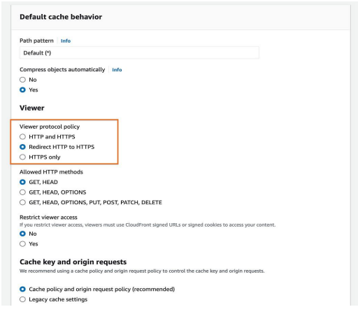
- Web Application Firewall (WAF) Select “Do not enable security protection
- Alternate domain name (CNAME): Add item and enter your domain name (in my case “anaquirosa.com”)
- Custom SSL certificate: Choose the created certificate.
- Remember, if you created it in a region other than us-east-1 (N. Virginia), it won’t appear in this list.
- Default root object: Type “index.html” (your default homepage) and• then click “Create distribution”.
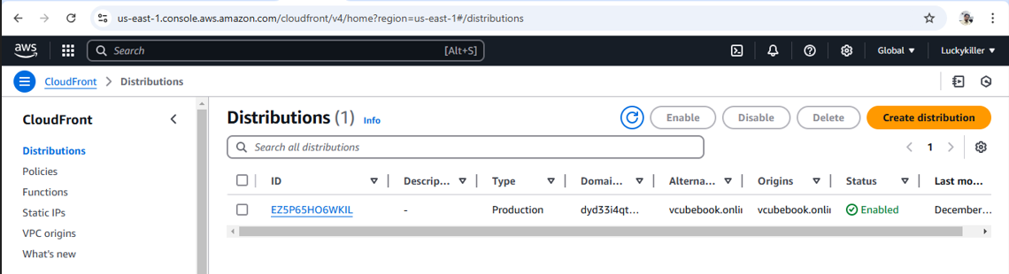

- Once distribution is created copy the distribution domain name which is showing in below figure
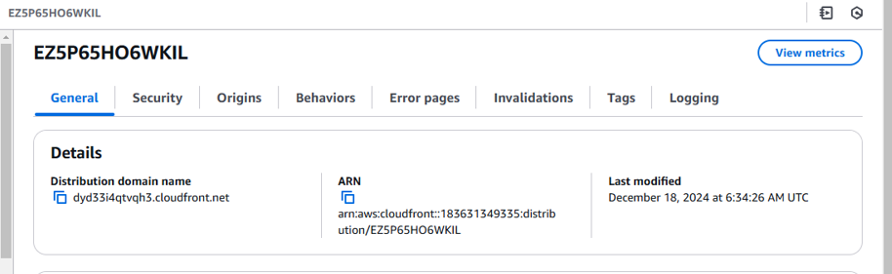

- Now copy the distribution domain name and paste it on web
- Now we can connect as secure connection
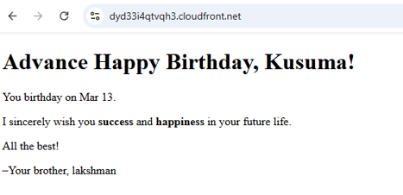
- Right now, Route 53 sends traffic to the S3 bucket.
- We want it to send traffic to the CloudFront distribution
- Goto route 53 and click on hosted zones
- Select the A record and then click Edit record
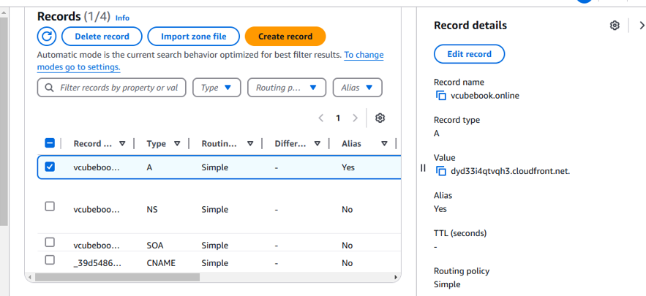
- Route traffic to: Alias to Cloudfront distribution.
- Choose Region: This option is selected for you and grayed out.
- Choose your distribution (it should automatically populate in thethird dropdown)
- Click Save
- Now can access our html file with domain name with secure connection shows in below figure
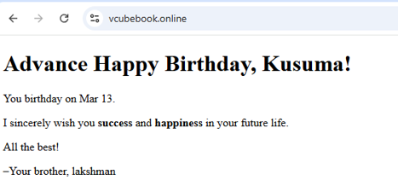
Final conclusion :
- Created a s3bucket and uploaded the .index file for static web hosting
- Created hosted zone with our domain name in route 53
- Onec we created we will get by default 2 records
- We need to create one more record to map our s3 web hosting to domain name
- Now we need to map our ns servers to domain name in hostinger
- Now we can access our html file with domain name

- Now we can access our frontpage through static web hosting and domain name
- Here our main aim is to connect as secure connection
- To connect secure we need to create certificate in ACM
- By using our certificate we need to create distribution in cloudfront
- Once distribution is created we can access secure connect with distribution domain name

